Homework

1. Implement the user register page by Spring MVC. Attention the View and Controller parts.
2. Add the validator by Spring Validator.

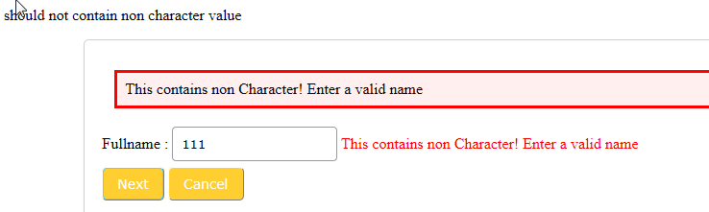

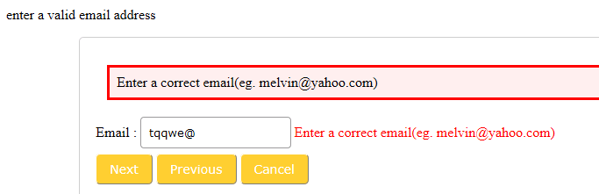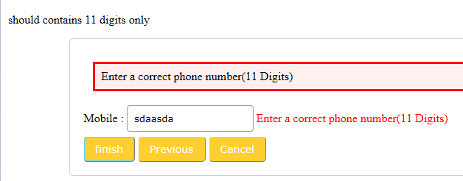

1. Use Spring multi form
2. Finish the unit test to test Spring Controller and Service
3. Review today’s PPT and sample codes.